Customer Test Program

Customer | : | Clyde Union LTD
Ultimate User | : | Total E&P Suriname B.V.
Customer Reference | : | 126-PUCE-0102AB
Pump Manufacturer | : | Clyde Union LTD
Flowserve Test Project | : | 2026RSD06TL
Seal type and size | : | HSH/HSH 5.500/5.500
Flowserve order no. | : | 400413673-000100 F001825156

Project | Prepared by | Approved by | Description | Date
2026RSD06TL | M. Tagzait |  |  | 15-Sep-2026

CONTENTS PAGE
1.0 Introduction 2
2.0 Objective 2
3.0 Field Conditions 2
4.0 Test Conditions 3
5.0 Test Seal Configuration 3
6.0 Test Set-up 4
7.0 Test Procedure 5
7.1 PRE-TEST WORK 5
7.2 DYNAMIC TEST 6
7.3 TEST PLANNING 6
Test 1 6
Test 2 6
7.4 MONITORING OF DYNAMIC TEST 7
7.5 POST TEST WORK 7
7.6 REPORTING 7
Appendix I Mechanical Seal Assembly Drawing 8
Appendix II Tester Assembly Drawing 9
Appendix III System Drawing 10
Appendix IV P&ID Test Unit System 11

Introduction
Late 2024, the HSH/HSH 5.500” was designed for the multistage BB5 HSBB5b 9x9x13-E34 pump from Cyde Union LTD Celeros.
The seals experienced several failures during FAT during short running time, referring to RCA on the subject. The latest agreed action is to test the seal for a longer running period to demonstrate the seal performance.
The original mechanical seal was supplied with flat silicon carbide faces on the inner seal a modification was suggested based on the RCA to improve the lubricity, promote leakage and reduce the damage seen on the inner seal.

Objective
The objective is to verify the seal performance of the HSH/HSH mechanical seal as per drawing F001825156 (Appendix I).
The acceptance criteria for test are:
- The expected normal barrier fluid consumptions rates are below 50 g/h per seal cartridge.
  - The expected normal barrier fluid consumption rate for the inner seal may vary with process pressure 5-50 g/h.
- No evidence of chipping or deterioration of the contact surfaces of the in- and outboard faces. Due to the use of hard faces, some contact traces can be expected.

Field Conditions
Seal type and size : HSH/HSH 5.500/5.500
Seal Configuration : Dual pressurized face to face
Material code : YXYX/YXYA
Pump fluid : Sea water & Produced water + sea water
Seal chamber pressure : 11.5 barG Norm, 34 barG
Product Temperature : 50°C
Barrier fluid : Potable Water and MEG/Water 50/50
Barrier pressure : 39 barG
Speed : 5200/5235/5610 rpm
API-plan : 53B with automatic refill unit
Flowserve order number : 400413673-000100
Assembly drawing : F001825156 (Appendix I)
System drawing : xxxxx (Appendix III)

Test Conditions
Job Seal type and size : HSH/HSH 5.500/5.500
Seal Configuration : Dual pressurized face to face
Material code : YXYX/YXYA
Pump fluid : NA
Seal chamber pressure : NA
Product Temperature : NA
Barrier fluid : Potable Water and MEG/Water 50/50
Barrier pressure : 39 barG
Barrier temperature : Approx. 35- 50°C (outlet cooler, inlet seal)
Speed : 5610 rpm
API-plan : 53B on the job seal
: 53B on plug seal
Barrier flow rate : To be defined.
Test assembly drawing : xxxxxx (Appendix II) Upgraded.

Test Seal Configuration

Inboard Seal : HSH-5.500
Stationary face : C0307304SL (75%)
Material : Reaction Bonded Silicon Carbide
Rotating Face : 4N10037SL
Material : Reaction Bonded Silicon Carbide

Outboard Seal : HSH-5.500
Stationary face : C0307304SL (75%)
Material : Reaction Bonded Silicon Carbide
Rotating Face : 3R14918SL
Material : Reaction Bonded Silicon Carbide

Test Set-up
The test will be executed on test rig B. This unit is equipped with a 65 kW, frequency driven motor. Seal will be built as per drawing F000904152 rev- (Appendix II). For testing, the seal with counterclockwise rotation (Free End seal) will be used.
The test housing and adapter sleeve will be assembled within maximum allowable angular and radial misalignment according to API-682 (fourth edition) section 6.1.2.8(b) and 6.1.2.13.
The barrier cavity in the job seal will be connected to the plan 53 reservoir and be filled and pressurized using the support system. The cooling coil in the plan 53 will be used to keep the temperature of the barrier around 35 - 50℃ out of the cooler, towards the seal.
Measuring the IB leakage is key in determining the success of the test. Since the IB leakage will be mixed with the barrier, it cannot be measured directly. By visually measuring the layer of water in the API Plan 53 reservoir, the amount of accumulated leakage can be calculated.
See Appendix IV for the P&ID of the test unit system.

Test Procedure

PRE-TEST WORK
- At first installation the alignment of the seal chamber will be measured and recorded.
- Prior to first installation all mechanical seal and test components will be inspected for proper construction, compliance to drawing and material.
- Check seal faces for flatness. If not flat within two light bands, re-lap the faces.
- A surface profile of the "running area" of both, the rotating and stationary faces will be recorded as well as the face roughness (Ra value).
- The mechanical seal cartridge will be assembled according installation instructions indicated on drawing xxxxxx rev. A (Appendix I).
- Seal cartridge will be installed on the test unit according drawing xxxxxx rev.- (Appendix II) and connected to the Plan 53B system.
- The barrier side will be statically pressurized to the dynamic test pressure for a period of 10 minutes to check the tightness of the mechanical seal assembly;
- The product side will be statically pressurized to the dynamic test pressure for a period of 10 minutes to check the tightness of the mechanical seal assembly;
- The breakout torque will be measured immediately after pressurizing and after 10 minutes of static pressurization.

DYNAMIC TEST
In all tests only the seal cartridge will be tested, no product side will be simulated.
The following tests are scheduled.
      - Dynamic test with the DE or NDE seal at the following conditions:
Test duration : 100 hours
Product fluid : NA
Barrier temperature : depends on how much heat will be generated.
Barrier pressure : 39 barG
Speed : 5610 rpm
Barrier pressure, face temperature and leakage of both inboard and outboard seal will be recorded.
      - Dynamic test with the DE or NDE seal at the following conditions:
Test duration : 100 hours
Product fluid : NA
Barrier temperature : depends on how much heat will be generated.
Barrier pressure : 46 barG
Speed : 5610 rpm
Barrier pressure, face temperature and leakage of both inboard and outboard seal will be recorded.

TEST PLANNING

Test 1
To be started on October 12, 2026

Test 2
To be started on October 19, 2026

MONITORING OF DYNAMIC TEST
Seal Performance, by means of a data acquisition system the following parameters will be recorded with an interval of 5 minutes:
- Barrier inlet temperature;
- Barrier outlet temperature;
- Barrier pressure;
- Speed;
- Torque.
By hand at regular intervals during day shift:
- Barrier inlet temperature;
- Barrier outlet temperature;
- Barrier pressure;
- Speed;
- Barrier flow rate;
- Leakage of in- and outboard seal;
- Torque.

POST TEST WORK
- Directly after the test is stopped the break-out torque will be measured under pressurized condition; This will be repeated 10 minutes after the first measurement;
- Drain seal and disassemble mechanical seal from test rig;
- The mechanical seal will be dismantled for inspection;
- Following parts of the job and plug seal will be inspected and observations recorded:
- Seal faces;
- Anti-rotating pins:
- Landing areas
- Balance diameters
- A surface profile of the "running area" of both the rotating and stationary faces of the job and plug seal will be recorded. The face roughness (Ra value) will be recorded in radial direction.
- Photographs of both rotating and stationary faces of the job and plug seal will be made.

REPORTING
- Every deviation from the test program will be recorded with a Test Program Change Notice (TCN);
- A detailed test report will be provided after completion of the complete test program.

- Mechanical Seal Assembly Drawing
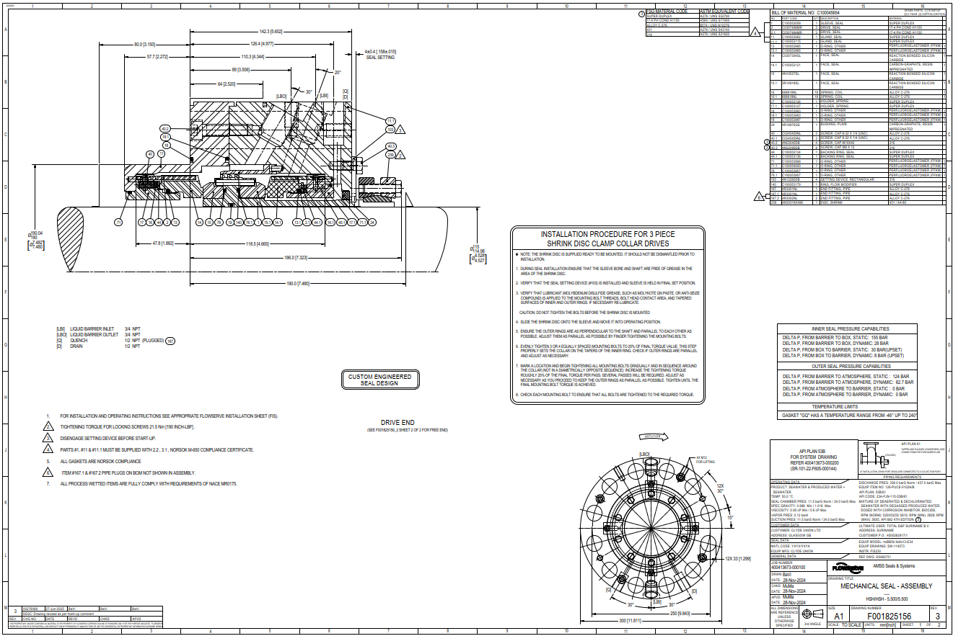
- Tester Assembly Drawing
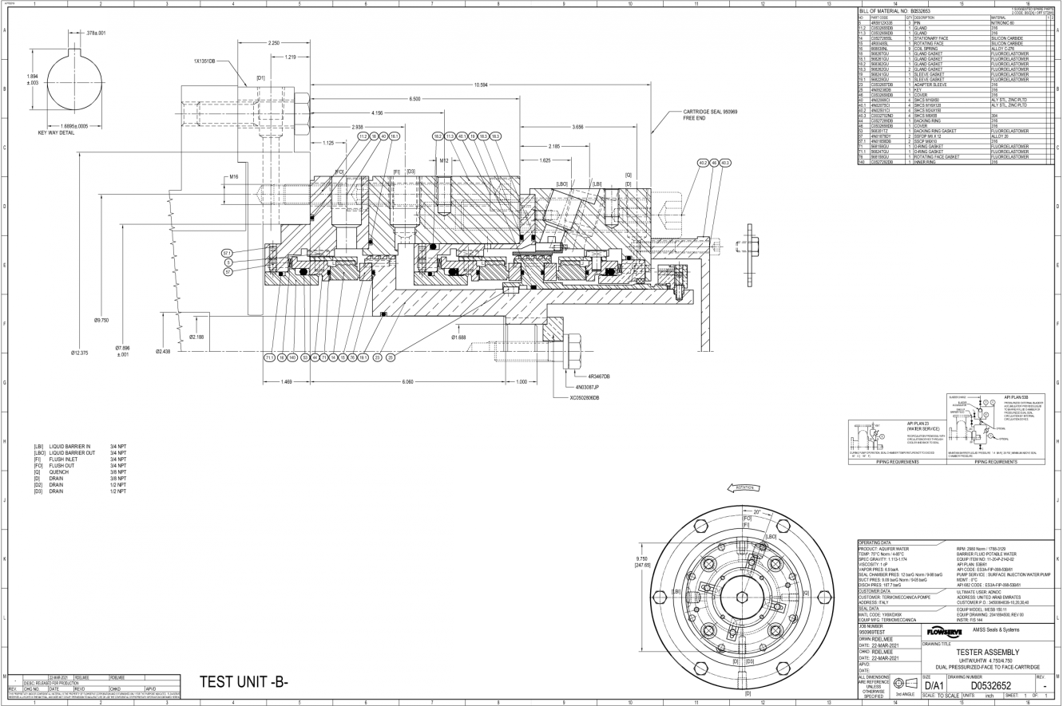
Drawing will be updated with the actual test drawing
- System Drawing
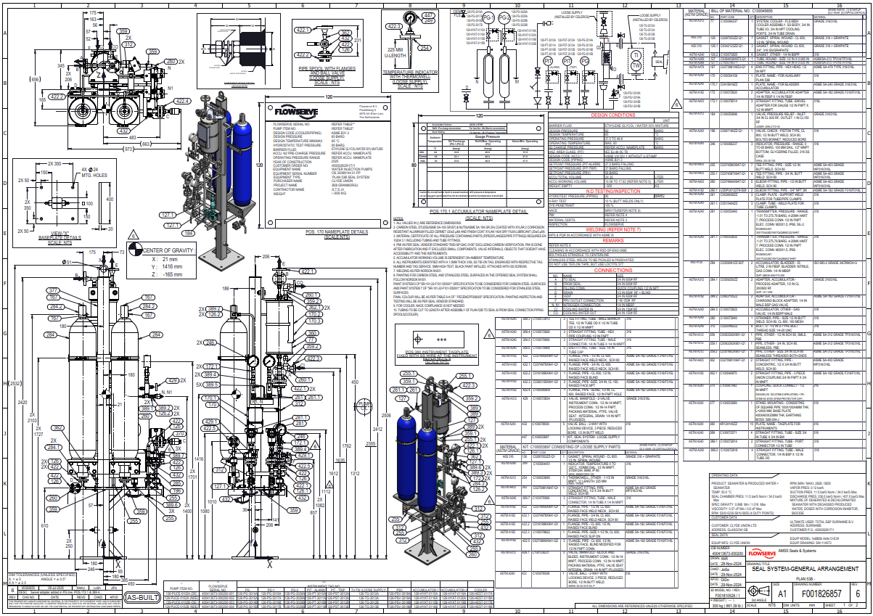
- P&ID Test Unit System
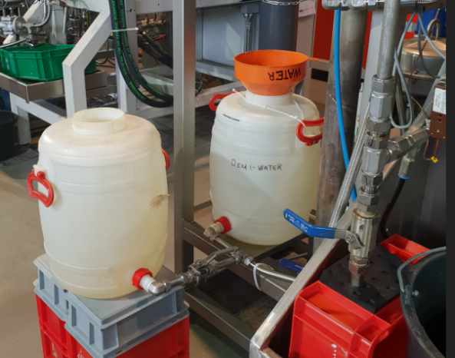
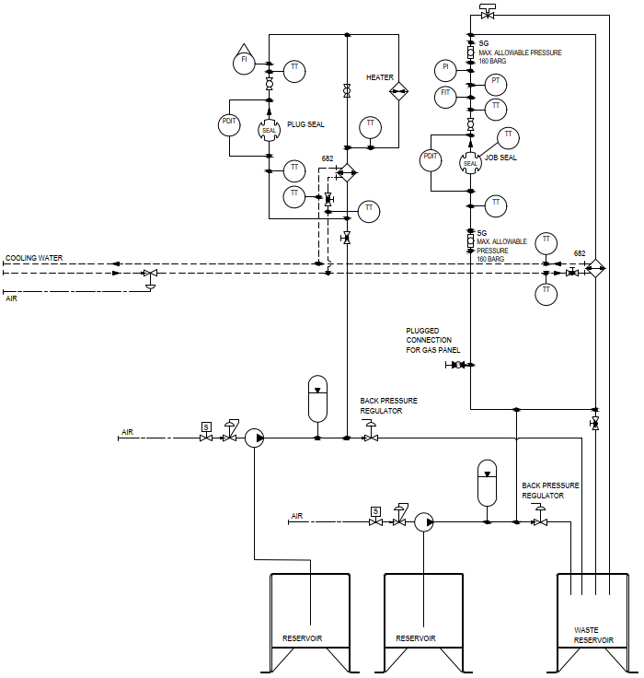
Job seal shall contain 2 drums for the barrier fluid to cope with the high barrier consumption.

